Module 2: Case Study – 1
Case-Study-–-EC2-EBS-EFS

Problem Statement:
You work for XYZ Corporation. Your corporation is working on an application and
they require secured web servers on Linux to launch the application.
Tasks To Be Performed:
1. Create an instance in the US-East-1 (N. Virginia) region with Linux OS and
manage the requirement of web servers of your company using AMI.
2. Replicate the instance in the US-West-2 (Oregon) region.
3. Build two EBS volumes and attach them to the instance in the US-East-1
(N. Virginia) region.
4. Delete one volume after detaching it and extend the size of the other
volume.
5. Take backup of this EBS volume.

Task1.
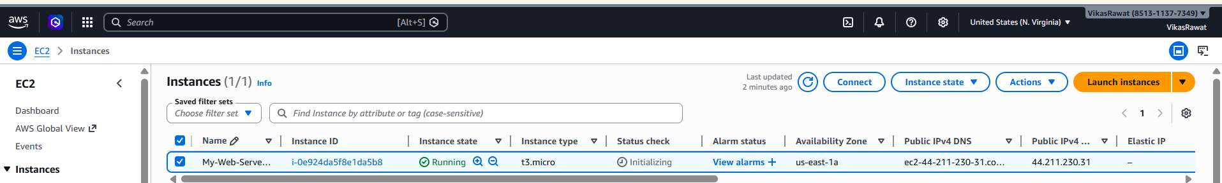
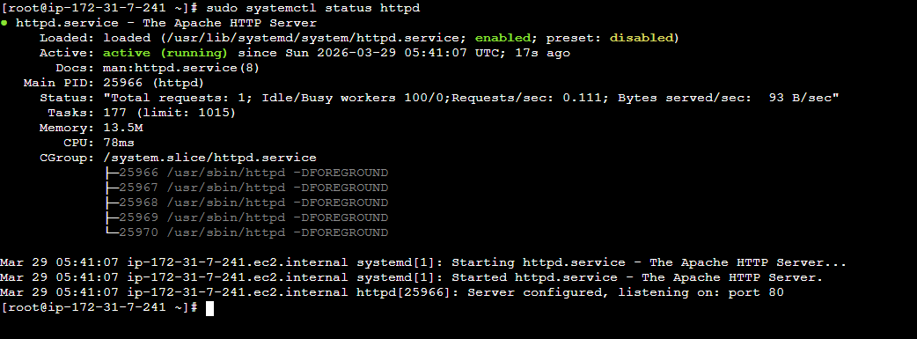
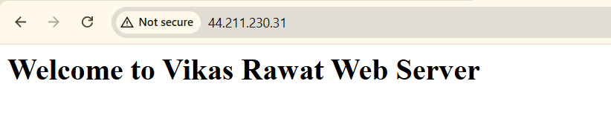
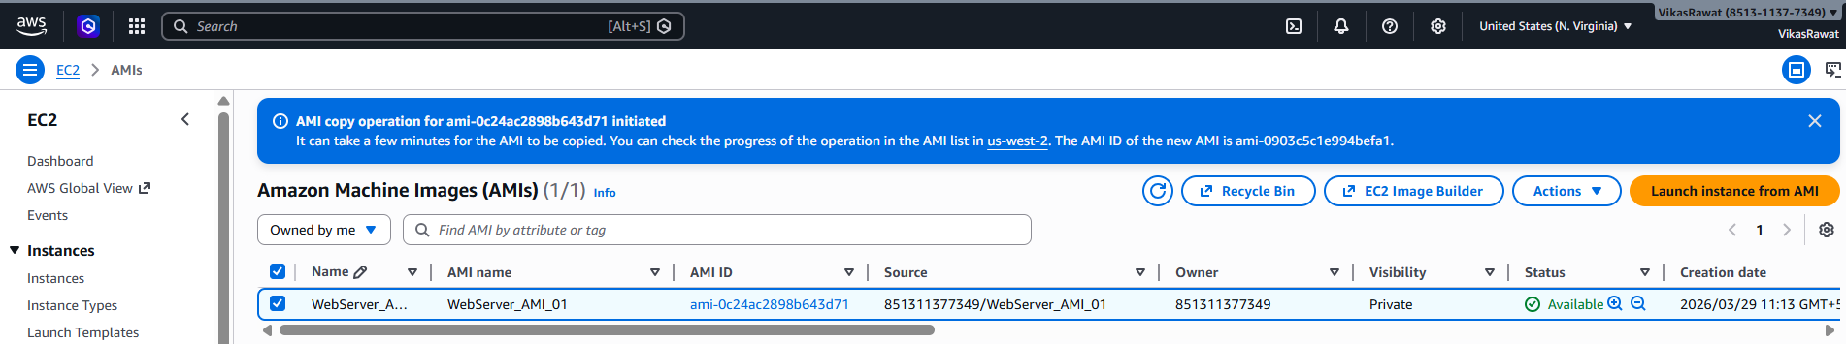

Task2.
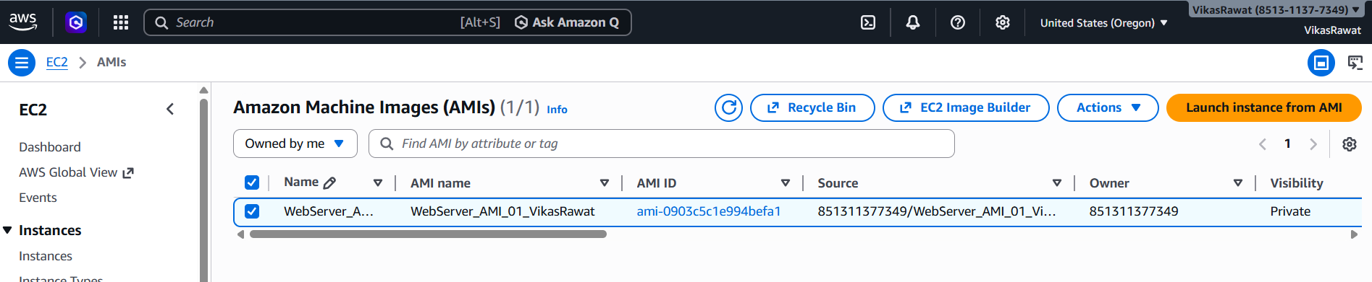
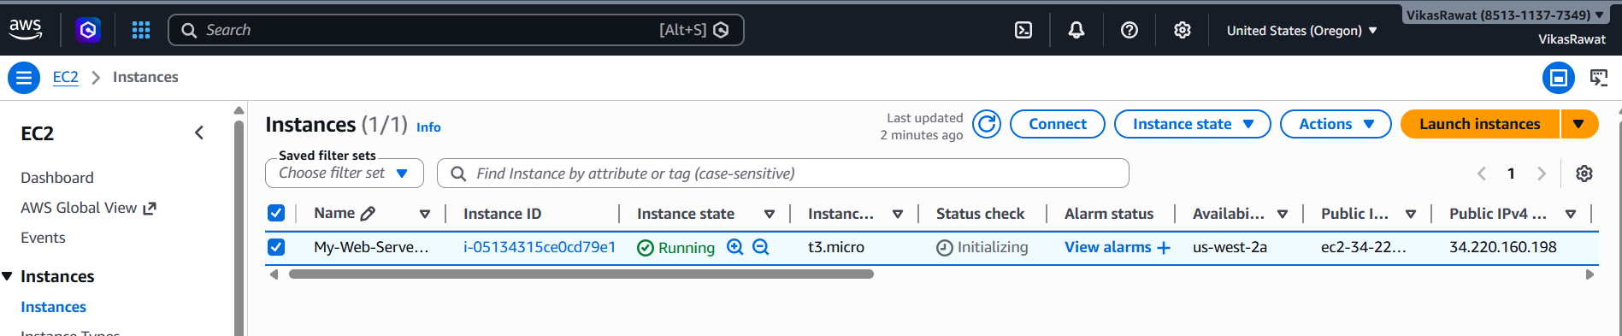
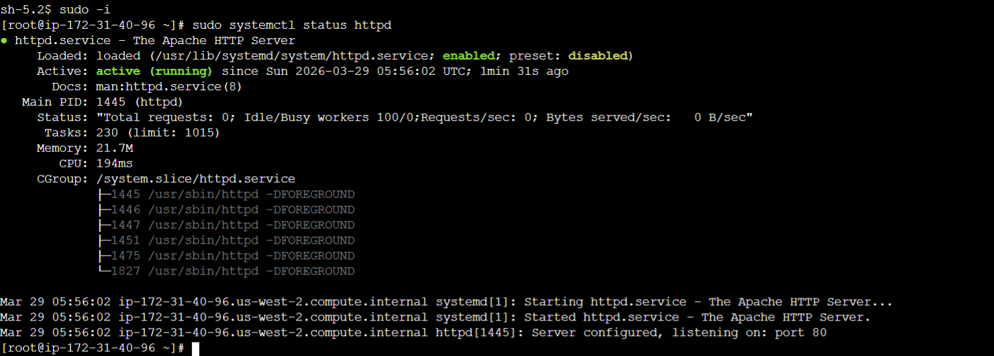
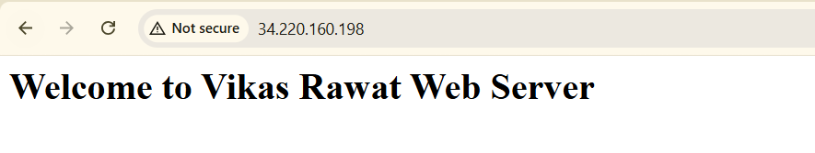
Task3.
